RFQ opening date: | July 27, 2022
RFQ closing date: | August 10, 2022, 11:00 a.m.

Project Overview:
This year the Downtown Milton Business Improvement Area (DMBIA) will be purchasing new side-mount seasonal LED light displays to decorate our historic downtown during the colder months. We will be purchasing between 25 and 45 pole mount displays (depending on budget) for street poles along Main Street East within the DMBIA district. We are seeking quotes from service providers who can:
- Remove the existing brackets from our street poles and install the new brackets
- Supply the displays and associated hardware
- Install the new displays
- Remove the displays at the end of the season
- Provide installation, storage and removal on an annual basis

Conditions:
- Display specifications – White or colour, minimum 4 ft in height, steel or aluminum frame with rust protection, UV-resistant, CSA approved. 120V outlet. Display must hang on the inside (roadside) of the pole because banners hang on the outside (sidewalk side) year-round.
- Installation must take place between November 13 and November 20, 2022. Removal will be in February/March 2023. Storage services must be available between seasons.

About the Downtown Milton Business Improvement Area:
The Downtown Milton Business Improvement Area (BIA) works to enhance and restore Downtown Milton and promote it as a vibrant and growing business community. We support local businesses, property owners and the community through beautification efforts, special events, marketing and promotions and strategic partnerships. For more information, visit www.downtownmilton.com.

Photos:
Previously wreaths were used. The new displays will replace the wreaths. | 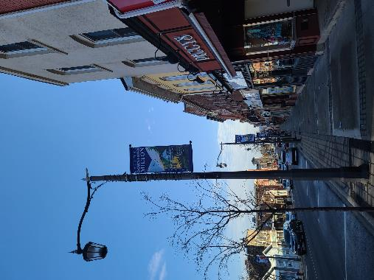  The new displays must be side-mounted and hang on the road side of the pole.

SUBMISSION FORM

Company and Contact:
Company name:
Address:
Company phone:
Website:
Contact name:
Contact email address:
Contact direct phone number:

Price List:
Please provide PER UNIT price for the following items.
Item | Unit Price (Excl HST)
Side-mount seasonal LED street pole mount display and hardware
Removal of old bracket/hardware
Installation of new bracket/hardware
Install display in November 2022
Annual installation, removal and storage (price per display per year)

Volume Discounts:
Are volume discounts available on the above pricing (ie for purchases of over 10 units, 20 units, 30 units, 40 units, etc.)? If so, please explain below and provide pricing.

Warranty:
What warranty is offered on your products and services? What additional warranty packages are available and what is the price?

More information:
Please share any additional notes, information or links.

Submission Instructions:
Please complete the above information and email this document, along with any additional information, samples, catalogues, etc. to Rachel Shuttleworth at r.shuttleworth@downtownmilton.com. The deadline for submissions is August 10, 2022 at 11:00 a.m.

